Parth Babbar

Enhancing Operational Efficiency and Financial Planning in Banking

AIM:
The aim of this report is to streamline operational operations and improve financial forecasting in the banking sector. The purpose of studying cash flow patterns, ATM maintenance data, financial product performance, and operational efficiency measures is to improve decision-making, increase efficiency, and generate more accurate financial projections.
Features:
1. Cash Flow Data and Forecasts:
- Year: Calendar year of data collection or application.
- Branch_ID: Unique identifier for each bank branch.
- Region: Geographic area of branch operations.
- Total_Cash_Inflow: Total cash entering the branch.
- Total_Cash_Outflow: Total cash leaving the branch.
- Net_Cash_Flow: Difference between inflow and outflow.
- Cash_Balance: Cash available at the end of the period.
- Forecasted_Cash_Inflow/Outflow/Net_Cash_Flow: Projected cash flows for budgeting and planning.
- Forecast_Accuracy_%: Accuracy of forecast models.
- Major_Events: Significant occurrences impacting cash flow.
2. ATM Maintenance and Performance Data:
- Year: Year of data collection.
- Branch_ID: Identifier for the branch where the ATM is located.
- Region: Location-based regional data.
- ATM_ID: Unique identifier for each ATM.
- Location: Type of area (Urban/Suburban/Rural).
- Transaction_Volume/Value: Number and value of ATM transactions.
- Cash_Dispensed/Loaded: Cash handled by the ATM.
- Downtime_hours: Hours ATM was out of service.
- Maintenance_Type/Cost: Type and cost of ATM maintenance.
- Customer_Complaints: Number of complaints regarding ATM.
- Average_Queue_Time: Average customer wait time.
3. Financial Product Sales and Performance Data:
- Year: Period of data collection.
- Branch_ID/Region: Identifiers for branch and location.
- Product_ID/Name/Category: Product details for tracking and analysis.
- Number_of_New_Accounts: New accounts opened.
- Total_Account_Balance: Sum of balances across accounts.
- Interest_Rate/Fee_Income: Interest rates and fee-generated revenue.
- Churn_Rate: Rate of account closures.
- Customer_Satisfaction_Score: Customer satisfaction with the product.
- Marketing_Spend: Amount spent on product marketing.
- Profitability_Margin: Profit margin from the product.
4. Operational Metrics and Efficiency Data:
- Year: Year of operational data.
- Branch_ID/Region: Identifiers for branch and location.
- Number_of_Employees: Total employees at the branch.
- Employee_Productivity: Measure of employee efficiency.
- Customer_Wait_Time: Average service wait time.
- Transaction_Processing_Time: Time to complete transactions.
- Error_Rate: Frequency of operational errors.
- System_Uptime_%: Percentage of operational system time.
- Digital_Channel_Usage_%: Usage of digital banking channels.
- Cost_per_Transaction: Cost incurred per transaction.
- Customer/Employee_Satisfaction_Score: Satisfaction metrics for customers and employees.
- Compliance_Score: Adherence to regulatory standards.
Methodology:
  - Data Collection: Information was collected from a variety of banking operations, such as cash flow, ATM maintenance, financial product performance, and operational indicators.
  - Data Modelling: Python was used to clean, transform, and analyse the data. By handling the missing values, remove outliers and reducing the duplicates.
  - Visualization: This project's visuals were developed with Power BI. The visualizations include dashboards for:
1. Cash flow forecasting and analysis
2. ATM maintenance and performance metrics.
3. Financial product performance trends
4. Operational efficiency metrics and insights
5. Summary
Output & Result Analysis:
1.Cash Flow Data:
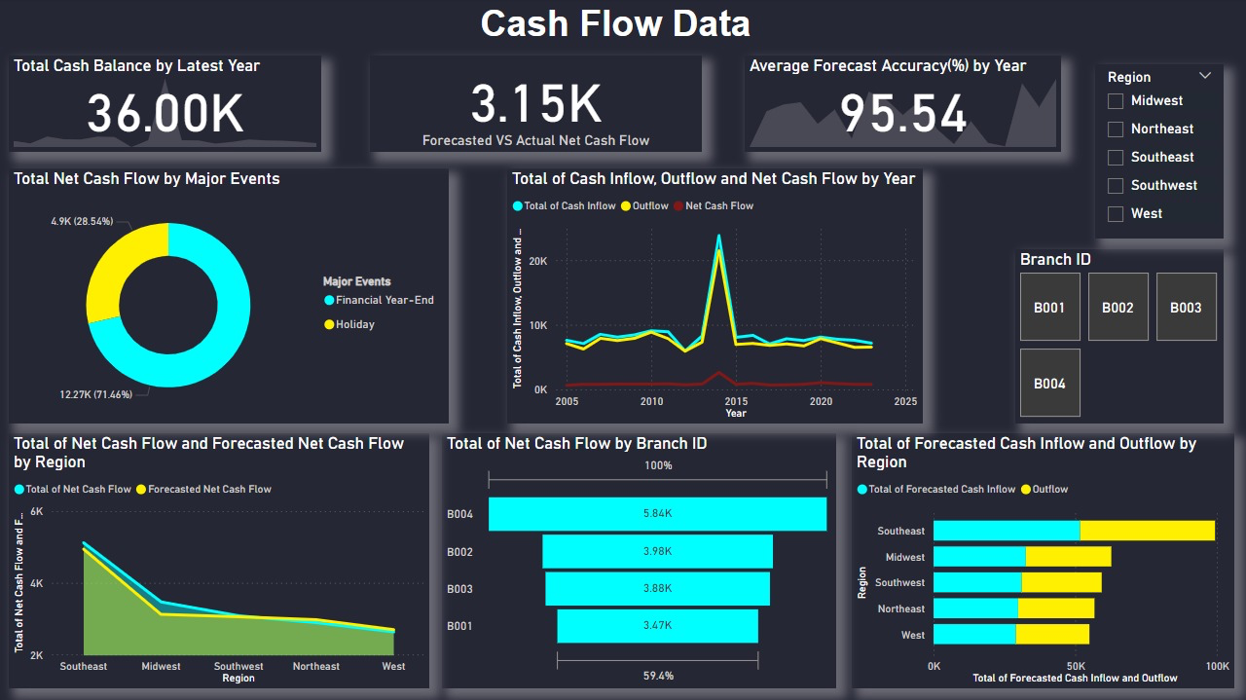
  - Cash Balance by Year: The most recent year's total cash balance is $36,000. The line chart indicates a very constant trend with small changes.
  - Forecasted Net Cash Flow Variance: The difference between anticipated and actual net cash flows is 3.15K.
  - Average forecast accuracy percentage by year: The high average prediction accuracy of 95.54% suggests that the cash flow estimates are quite trustworthy and accurate.
  - Net Cash Flow by Major Events: Financial year-end events have a substantially greater influence on net cash flow than holidays, indicating that big financial activity or transactions take place near the conclusion of the year.
  - Total Cash Inflow, Cash Outflow, and Net Cash Flow by Year: This graph depicts trends from 2005 to 2025.A noteworthy peak appears around 2015, indicating a substantial financial event or boost in activity during that year. The overall trend is quite constant, with slight changes, indicating solid cash flow management.
  - Net Cash Flow by Branch ID: B004 is the best performer, with the greatest net cash flow, while B001 has the lowest. This might suggest improved performance, efficiency, or increased activities at B004.
  - Net Cash Flow and predicted Net Cash Flow by Region: The Southeast has the greatest net cash flow and predicted net cash flow, followed by the Midwest and other areas. This identifies the Southeast as the most important contributor to the company's cash flow and indicates a high level of financial activity in the area.
  - Forecast Cash Inflow and Outflow by Region: The Southeast continues to dominate in both expected cash inflow and outflow, reflecting a strong level of financial activity. Other regions (Midwest, Southwest, Northeast, and West) exhibit lower but stable numbers, indicating ongoing financial activity.
2.ATM Maintenance Data:
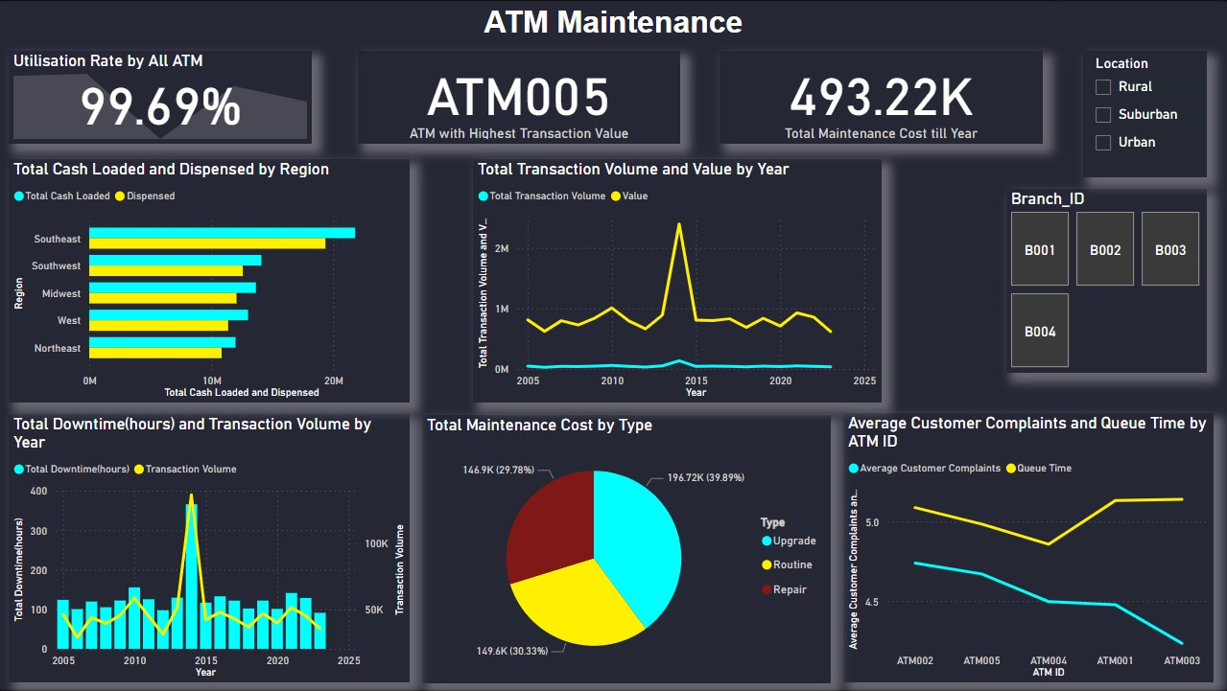
  - Utilization Rate by All ATMs: The utilization rate is extraordinarily high, at 99.69%, suggesting that the ATMs are nearly full capacity.
  - ATM with greatest Transaction Value: ATM005 has the greatest transaction value, indicating that it is an important asset.
  - Total Maintenance Cost: The entire maintenance cost for the year to date is $493.22K. This covers all sorts of maintenance (upgrade, regular, and repair).
  - Total Cash Loaded and Dispensed by area: The Southeast area has the most total cash loaded and disbursed, showing significant demand and consumption. Other regions, including the Southwest, Midwest, West, and Northeast, follow in decreasing order of cash transactions.
  - Total Transaction Volume and Value by Year: Transaction volume and value rise around 2015, then fall. The chart shows varied amounts of ATM usage throughout time, with a big peak and then stabilization.
  - Total Downtime and Transaction Volume by Year: Downtime hours vary but peak at the same time that transaction volume does (about 2015).This shows that increasing transaction volumes may necessitate more maintenance or repair work, resulting in additional downtime.
  - Total Maintenance Cost by Type: The expenditures are split between upgrades (29.78%), normal maintenance (30.33%), and repairs (39.89%).Repairs account for the majority of maintenance expenses, highlighting possible areas for improvement in lowering repair frequency.
  - Average Customer Complaints and Queue Time by ATM ID: Customer complaints and queue times differ depending on ATM despite having the largest transaction value, ATM005 has managed to maintain very low complaints and queue times.ATM003 has the longest backlog times, suggesting a possible need for more resources or increased efficiency.
3.Financial Products and Performance Data:
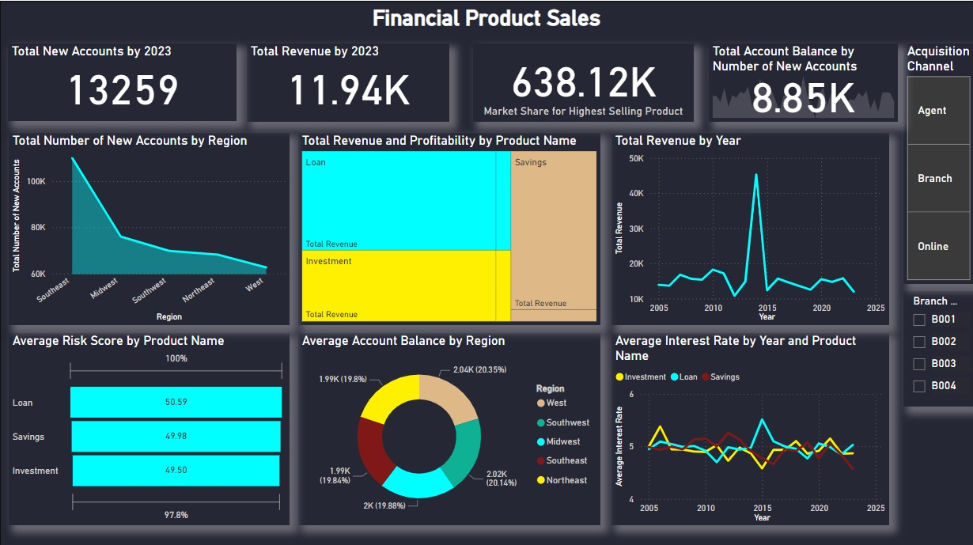
  - Total New Accounts by 2023: This metric represents the number of new accounts opened by 2023, reflecting client acquisition activities.
  - Total Revenue by 2023: This figure represents the total revenue earned by the end of 2023, reflecting the financial performance of your products.
  - Market Share for Highest Selling Product: This indicator shows the market share of the best-selling financial product, showing its popularity and penetration.
  - Total Account Balance by Number of New Accounts: This shows the total balance of new accounts, which provides information on new customers' financial activity.
  - Total number of new accounts by region: The Southeast leads in new accounts with more than 100,000, followed by the Midwest, Southwest, Northeast, and West. Marketing is most effective in the Southeast, but there are chances for development in other regions with increased outreach efforts.
  - Total Revenue and Profitability by Product Name: Loan products provide the most revenue, followed by savings and investments. Loans are the most profitable, implying that expanding and improving loan services might boost income.
  - Total Revenue by Year: Revenue peaked about 2015 and subsequently varied in a general declining pattern till 2025. The high in 2015 demonstrates good performance at the time, but the drop suggests the necessity for revenue development initiatives.
  - Average Risk Score by Product Name: Risk ratings are very evenly distributed across categories, with loans at 50.59, savings at 49.98, and investments at 49.50. Loans have the highest average risk, thus risk management measures should be especially strong for them.
  - Average Account Balance by Region: The Northeast and Southeast had the highest average balances, around 2.04K and 2.02K, respectively. Other regions, such as the West, Midwest, and Southwest, have balances ranging from $1.99 to $2,000. This shows that the Northeast and Southeast have more affluent or engaged clients.
  - Average Interest Rate by Year and Product Name: Loans peaked about 2015 before stabilizing, whilst investments and savings vary but are rather steady. This shows that loan interest rates may change in response to revenue peaks and troughs. Interest rate stabilization might help to ensure consistent revenue.
4.Operational Metrics Data:
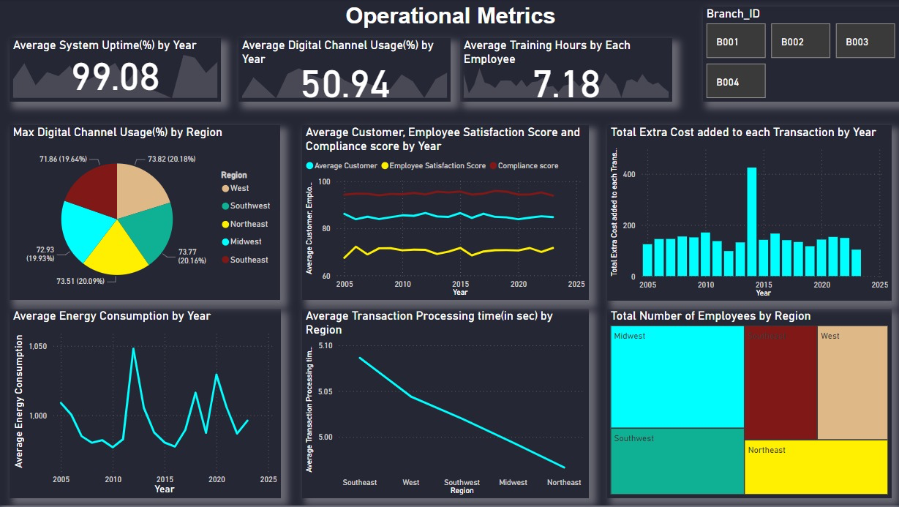
- Average System Uptime (%) by Year: This demonstrates a highly dependable system with minimum downtime over time.
- Average Digital-Channel-Usage (%) by Year: Indicates that little over half of contacts or transactions take place via digital channels.
- Average Training Hours Per Employee: Each employee receives around 7 hours of training on average, demonstrating a commitment to continued education and skill development.
- Max Digital Channel Usage (%) by Region: Digital channel usage is pretty evenly distributed among regions, with the Southwest leading with 73.82%.The Midwest, Southeast, and Northeast follow closely, with 73.77%, 73.51%, and 72.93%, respectively. The West has the lowest utilization, although it remains considerable at 71.86%.
- Average Transaction Processing Time (in seconds) by Region: The Northeast has the fastest transaction processing time of 4.95 seconds. Other regions are likewise efficient: the Midwest (5.00 seconds), Southeast (5.02 seconds), West (5.05 seconds), and Southwest (5.10 seconds).
- Average Energy Consumption by Year: Displays a varied pattern with peaks and troughs. The largest peaks occur between 2010 and 2015, with a general declining trend until 2025.
- Total Extra Cost Added to Each Transaction by Year: There is a big spike around 2015, indicating a one-time cost increase. Other years indicate pretty consistent expenses.
- Average Customer, Employee Satisfaction, and Compliance Scores by Year: Customer satisfaction has remained consistent and somewhat rising over time. Employee satisfaction levels stay consistent over time. The compliance score is lower than the satisfaction score, with minor variations but generally constant.
- Total Number of Employees by Region: The Midwest has the most employees, followed by the Southwest, Southeast, and northeast. The West has the fewest amount of employees.
5.Summary:
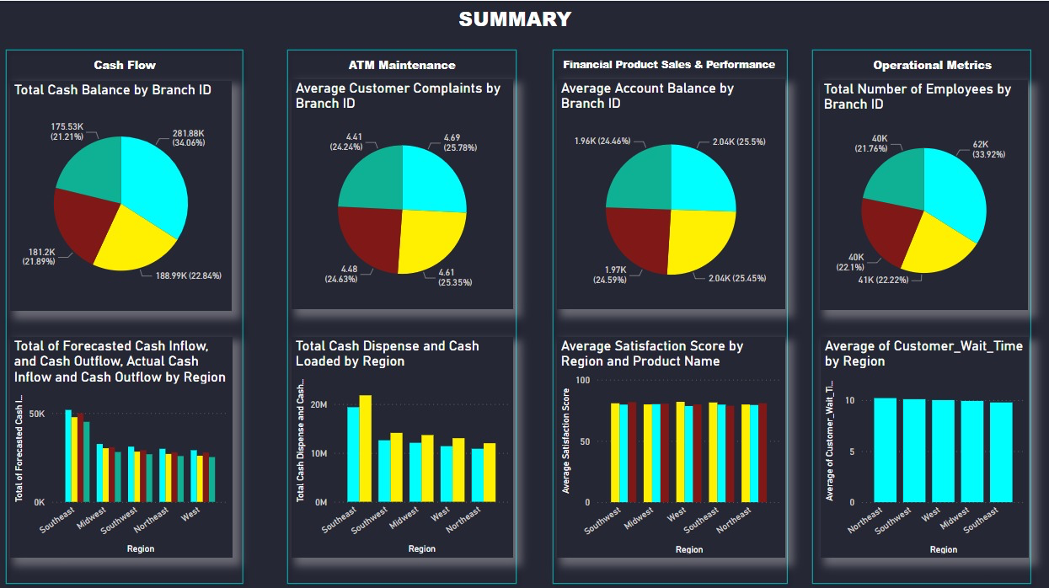
1.Cash Flow:
1.Total Cash Balance by Branch ID: The pie chart depicts the distribution of cash balances among four branches. Branch 4 has the greatest cash balance of $281.88K, followed by Branch 2 with $188.99K. Branch 3 is next with $181.2K, while Branch 1 has the least cash balance of $175.53k.
2.Total Forecasted Cash Inflow, Cash Outflow, Actual Cash Inflow, and Cash Outflow by Region: The bar chart compares expected and actual cash inflows and outflows across areas. The Southeast area has the highest numbers for both projected and actual inflows and outflows. The Midwest and Southwest areas have intermediate levels, but the Northeast and West have the lowest figures in each category.
2.ATM Maintenance:
1.Average Customer Complaints by Branch ID: This pie chart depicts the distribution of average customer complaints across four branches. Branch 3 has the greatest average number of complaints (4.69), closely followed by Branch 2 (4.61). Branch 4 averages 4.48 complaints, while Branch 1 has the lowest average of 4.41 complaints.
2.Total Cash disbursed and Loaded by Region: The bar chart compares the total cash disbursed and loaded in different areas. The Southeast area has the highest figures for cash distributed and loaded. The Midwest, Southwest, and West areas have intermediate levels, but the Northeast has the lowest figures.
3.Financial Product Sales & Performance:
1.Average Account Balance by Branch ID: This pie chart depicts the distribution of average account balances across four branches. Branch 4 and Branch 3 had the highest average account balances of $2.04K. Branch 1 follows closely with an average balance of $1.97K, while Branch 2 has the lowest average balance of $1.96K.
2. Average Satisfaction Score by Region and Product Name: The bar chart depicts the average satisfaction scores for various geographies and product categories. The scores are highly comparable throughout all locations, with only minor differences noted, reflecting a consistent degree of client satisfaction throughout.
4.Operational Metrics:
1.Total Number of personnel by Branch ID: A pie chart depicts the distribution of personnel among four branches. Branch 4 has the most employees, totalling 62K. Branch 3 follows with 41K employees, while Branch 1 has 39.6K. Branch 2 has somewhat more staff, totalling 40.2K.
2.Average Customer Wait Time by Region: The bar chart shows the average customer wait time for different areas. The findings show that all regions had a comparable average wait time of about 10 minutes, with just slight differences.
Summary:
- In terms of cash flow and financial measures, the Southeast region and Branch B004 stand out, whereas other areas and branches perform differently.
- High ATM use and maintenance costs indicate a need for efficiency improvements, notably in decreasing repair requirements and controlling transaction volumes.
- Financial goods, particularly loans, are critical for income but carry more risk, demanding improved risk management methods.
- Operational metrics show high system dependability and digital channel utilization, but there is still space to increase compliance scores and better control expenses.

